Project Design Phase Problem–SolutionFitTemplate

|  |  |
| --- | --- |
| Date | 3 July 2025 |
| TeamID | LTVIP2025TMID60948 |
| ProjectName | Measuringthepulseofprosperity:anindexof  economicfreedom |
| MaximumMarks | 2 Marks |

**Problem – Solution Fit Template:**The Problem-Solution Fit simply means that you have found a problem with your customer and that the solution you have realized for it actually solves the customer’sproblem.Ithelpsentrepreneurs,marketersandcorporateinnovatorsidentifybehavioral patterns and recognize what would work and why

# Purpose:

* Solvecomplexproblemsinawaythatfitsthestateofyourcustomers.
* Succeedfasterandincreaseyoursolutionadoptionbytappingintoexistingmediumsand channels of behavior.
* Sharpenyourcommunicationandmarketingstrategywiththerighttriggersandmessaging.
* Increasetouch-pointswithyourcompanybyfindingtherightproblem-behaviorfitand building trust by solving frequent annoyances, or urgent or costly problems.

# Understandtheexistingsituationinordertoimproveitforyourtargetgroup. Template:

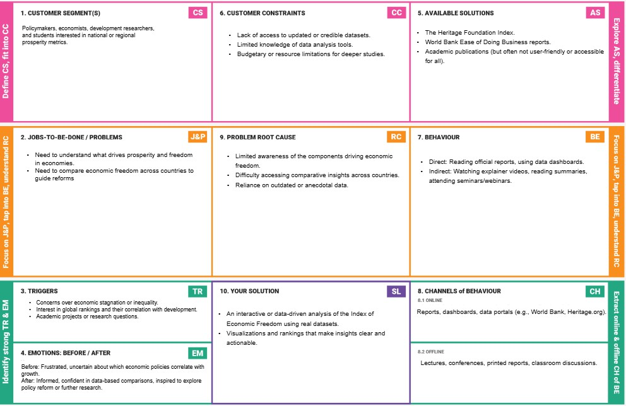

References:

1. <https://www.ideahackers.network/problem-solution-fit-canvas/>
2. [https://medium.com/@epicantus/problem-solution-fit-canvas-aa3dd59cb4fe](https://medium.com/%40epicantus/problem-solution-fit-canvas-aa3dd59cb4fe)